PAX Case Cir. Connector
Amphe-Lite AL06F21-41P

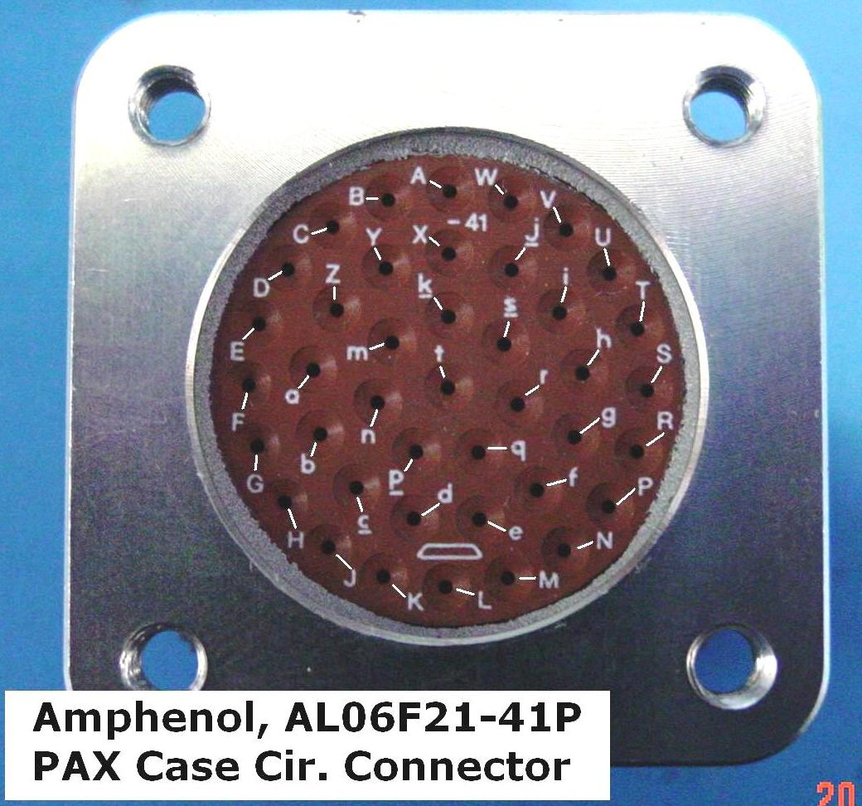
TEC Power 2 pins
New -42
p TEC Power + red
q TEC Power - black (blue)

TEC Control 6 pins
a Heat Sink Temp white Z (twisted pairs)
G Heat Sink Temp white Z
b Pax Temp blue Y
H Pax Temp blue Y
c Airstream Temp green X
J Airstream Temp green X

Cryo Power 4 pins
d Cryo Power + white
K Cryo Power + white
e Cryo Power - black
M Cryo Power - black
Shield grnd gray
Cooled Feed
Cryo Temp 2 pins
D Cryo Temp 1 white
E Cryo Temp 2 black
Shield grnd gray

Dewar Temp 2 pins
U Dewar Temp 1 white
T Dewar Temp 2 black
Shield grnd gray
PAX Control 12 pins New 2010 ID letters move around
Z Grnd OTXTEC black Z Back View (inside Pax Case)
Y +5V OTXTEC red Z “A” position is at 12:00/ L position is at 6:00
B Grnd OTX laser / PAM black Y
C +6V OTX laser / PAM green (gray) Y
k Gnd Sense black
s +6 Sense green (blue)(gray)
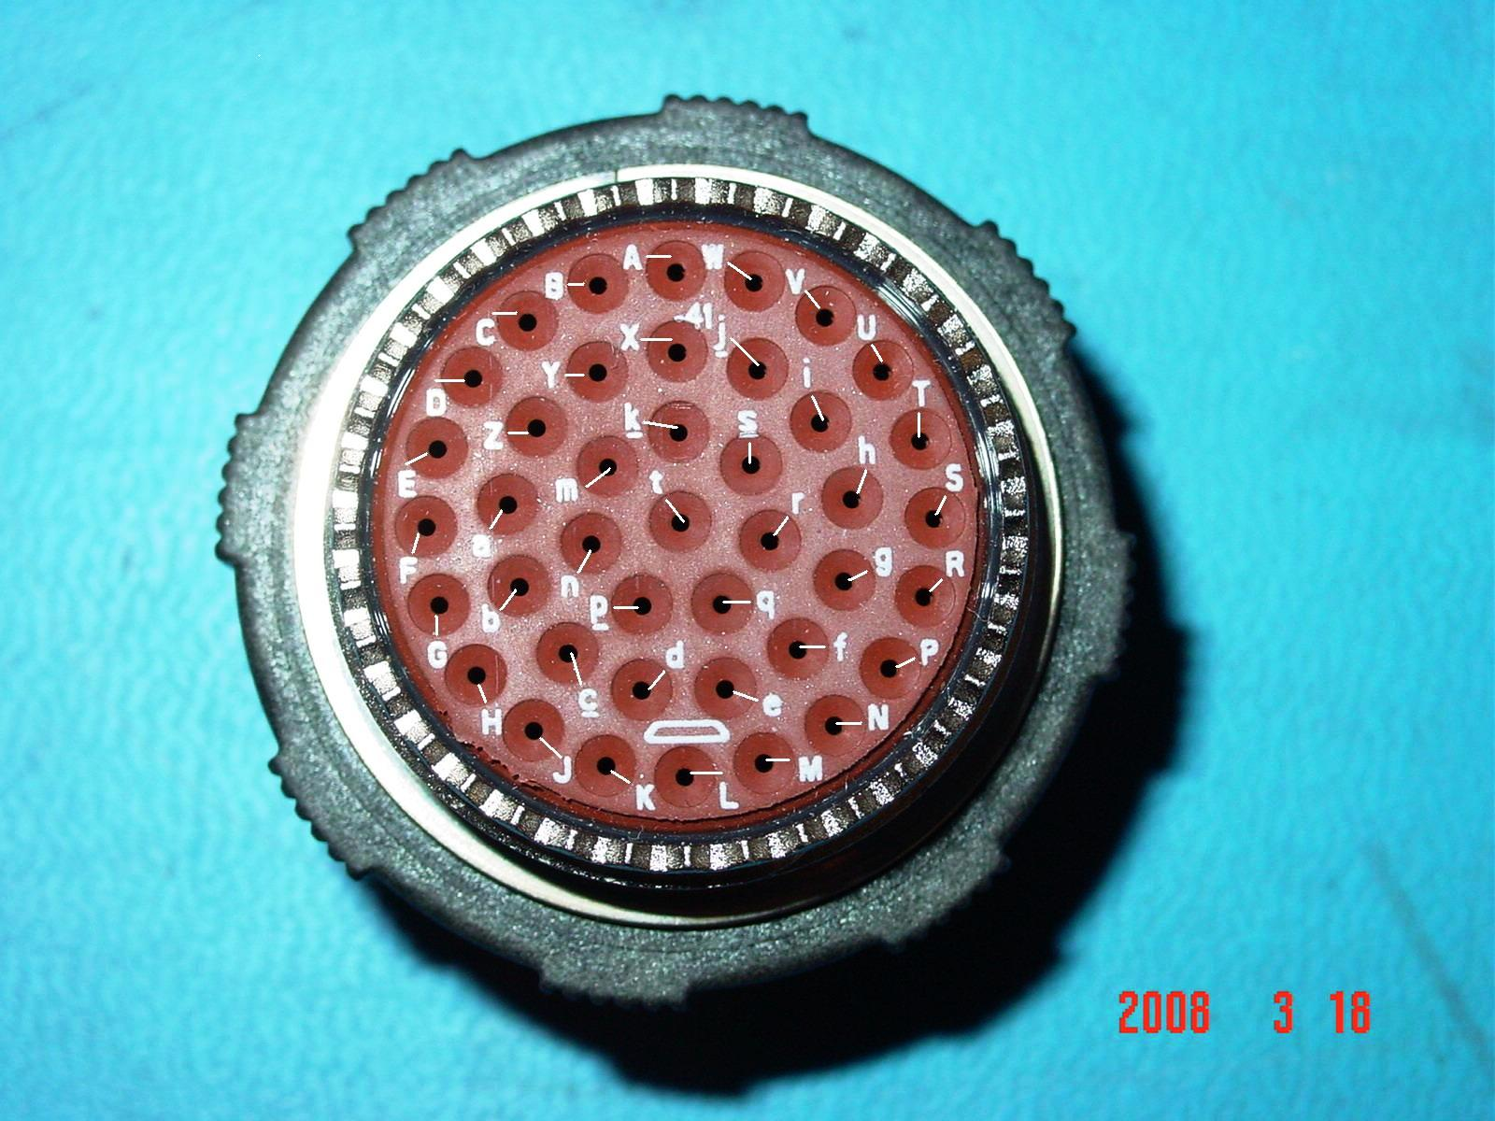
X +5 Sense red
m -6 Sense blue (black)
Old -42
i Grnd OTXTEC black X
j +5V OTXTEC red X
V Grnd OTX / PAM black W
W -6V OTX / PAM blue W
Ion Pump Control 6 pins (11”)
f Current monitor blue
g External reset white
h Power +12 VDC red
r Power com black
P Fault high voltage brown
R Fault blown fuse gray

Pax Case/ Rim Box Ground 1 pin (3-1/2”)
L Grounded to case green

Connector Positions Not Used
A
N
n
S
t

